FEAR - DESTRUCTION - EXPLOSIVE OXYGEN TANK

1 Introduction 2
2 creation 2
2.1 Creating the tank 2
2.2 Adding the Physics Collision Shapes 2
2.3 Place the SoundFX 3
2.4 Place the Particle Effects 5
2.5 Place the Explosion Object 6
2.6 Place the Impulse 7
2.7 Parenting 8
2.8 Script It Baby 9
2.9 Damage Properties of the Tank 10
2.10 Save, Compile And Run 10

Introduction

We’re going to create an explosive oxygen tank that when damaged, will spit out a pillar of fire that will propel it around a room, banging into objects in its way and eventually exploding into flames and smoke.

This tutorial assumes the reader is already familiar with placing objects in the editor, scripting, physical items and the basics involved in destructive events (covered in “FEAR - Destruction - General Overview.doc”).

creation

Creating the tank

First we need some sort of a room to work in, and then the metal tank itself needs to be created. Luckily for you a good tank prefab has already been constructed and can be found in the prefabs folder in Industrial/Interactive/Hydrogen-tank01. So, make a basic room, light and sector it and then place down that tank prefab.
The first thing we want to do is to turn the tank prefab into a WorldModel.
- You can do this by centering your marker somewhere in the center of the tank prefab and adding a WorldModel (Right click – Add - Object – WorldModel). Once you’ve placed the WorldModel, name it something unique like oxy-tank.
- Now, make the tank prefab a Child of the oxy-tank WorldModel. You can do this by selecting the tank prefab, then Right clicking on the oxy-tank WorldModel and choosing “Move Tagged Nodes Here” from the context menu. This will move the tank prefab under the WorldModel, making it a child of the WorldModel.
- Now, select JUST the tank WorldModel (Left click while holding Shift) to bring up its properties. Set the following properties:
  - CollisionProperties: AcetaleneTank
    - CollisionProperties controls how a physical item reacts when it runs into or hits another object in the world. It controls the sound it makes on collision and the particle effect that it shoots out (sparks, blood etc).
  - BoxPhysics: False
  - IsKeyframed: False
  - RigidBody: True
  - PhysicsShape: None

Adding the Physics Collision Shapes

- Right click the WorldModel, “oxy-tank” and choose “Set Active Parent.” This will make it so every new item you place now will be a child of the “oxy-tank” WorldModel.
- Now place a PhysicsShapeOBB and size it to be the same length as the tank itself (excluding the valve on the top), and make it quite a bit thinner than the circumference of the tank. You can check out the photo directly below to get an idea of the proper sizes. The PhysicsShapeOBB is the red rectangle in the middle of the tank.
- Next a PhysicsShapeCapsule is needed. Place one down and size it to cover just the tank and the valve as close as possibly. Size the radius of the PhysicsShapeCapsule to match the radius of the tank. This will make the tank roll when on its side. The PhysicsShapeOBB was placed to act as the end caps for the tank to stand on if the tank was placed standing up, so the OBB should extend just a little past the Capsule. Here is a reference picture (the white lines being the brushes which make up the tank, the red being the OBB and the blue being the Capsule).
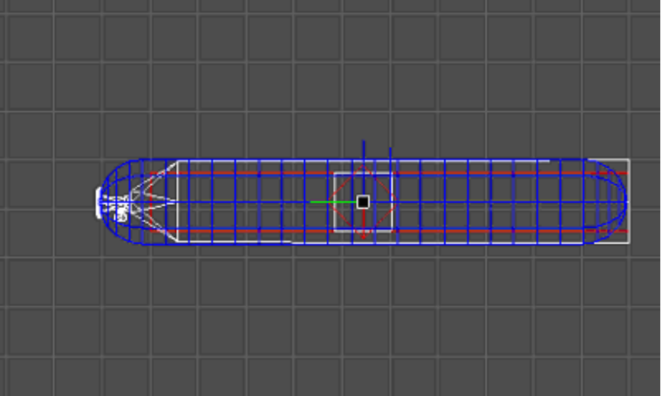
- Set the MassKg of the OBB to 10 and set the Capsule to 10 as well. The DensityG controls how easily a physical object will pass through other physics objects and let other objects pass through itself. This is mainly for Water Bodies (which are physics objects themselves), but in my experience it DOES affect all physical items as well. The default of 1.1 is good enough for the oxygen tanks.

Place the SoundFX

- Now we need to add the SoundFX objects that will play the sounds of the tank spewing flames and when it explodes. We will place a total of 3 SoundFX objects. The actual placement of the SoundFX objects is not overly important, but obviously you’ll want to place them as close to the tank as possible. Here is a picture of with example placements.
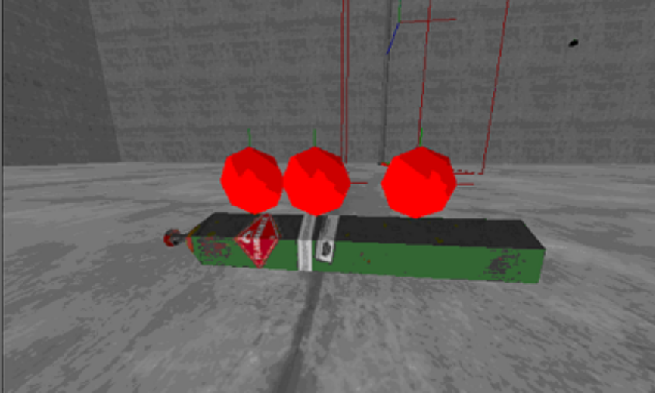
- So, place the SoundFX objects and name these new SoundFX SND00, SND01 and SND02.
- For SND00, set the following:
StartOn: False
Sound: Snd\Events\BET_pipe_explosion_camera.wav
OuterRadius: 16000
InnerRadius: 8000
Volume: 500
Ambient: True
Loop: False
MixChannel: 1
UseOcclusion: None
- For SND01, set the following:
StartOn: False
Sound: guns\Snd\Impacts\explosions\extinguisher_02.WAV
OuterRadius: 20000
InnerRadius: 16000
Volume: 500
Ambient: True
Loop: False
MixChannel: 1
UseOcclusion: None
- For SND02, set the following:
StartOn: False
Sound: guns\Snd\Impacts\explosions\explode_02.WAV
OuterRadius: 20000
InnerRadius: 16000
Volume: 500
Ambient: True
Loop: False
MixChannel: 1
UseOcclusion: None

Place the Particle Effects

Next we have to place down the SpecialFX objects that will visually represent the smoke and fire. The first one we will place will be the smoke that trails behind the tank as it whips around. For SpecialFX it makes a difference WHERE you place them and what DIRECTION you make them face.

- So, place the 1st SpecialFX at the position of the valve on the top of the tank and name it SpEFX00.
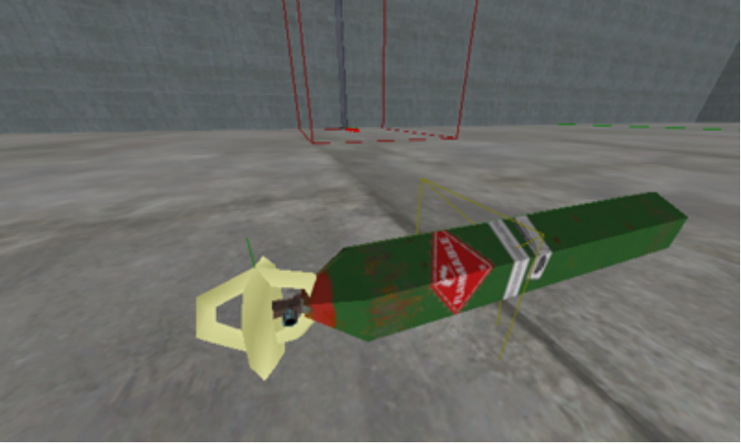
Then set its Rotation to (0, 0, 0) and set its TargetObject to the name of your tank WorldModel, in this case, “oxy-tank”. Set the following flags:
FxName: Smoke_DebrisTrail_Big
Loop: True
StartOn: False
- Place the 2nd SpecialFX object at the valve as well, and name it SpEFX01.
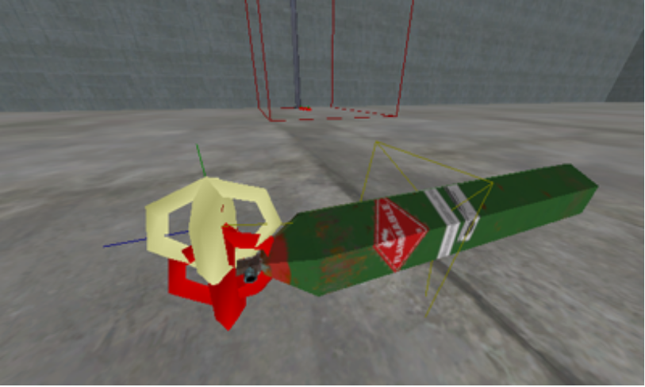
For the Rotation, set the YAW to 270. You want the blue line facing AWAY from the tank body, as this will simulate the flames spewing out of the valve.
Then, set the following flags:
FxName: Fire_Gas_30cm
Loop: True
StartOn: False
TargetObject: oxy-tank
- Place the 3rd SpecialFX object (it’s placing is not overly important as long as it is close to the tank, I placed mine right in front of the first two FX I had placed) and name it SpEFX02.
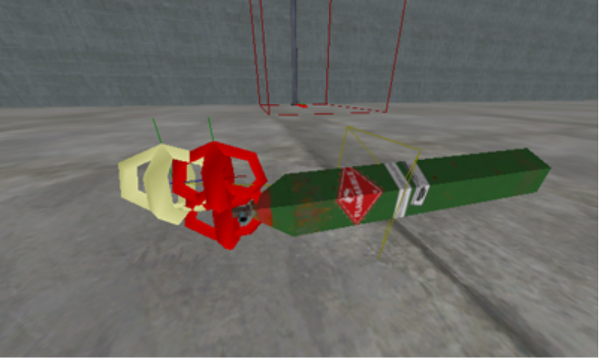
The Rotation for this FX does not matter. This FX will be the extra “view shake” when the tank finally explodes. Now, set the following flags:
FxName: Shake_Mild_1s
Loop: False
StartOn: False
- Place the 4th and last SpecialFX object (it’s placing is not overly important as long as it is close to the tank). Name it SpEFX03. This FX will serve as the explosion’s visuals (blast, smoke, etc). This FX also contains an explosion sound. Set the following flags:
FxName: Impact_Nade
Loop: False
StartOn: False

Place the Explosion Object

Now place an Explosion object that will actually do damage to the surrounding area when the tank explodes.
- Place the Explosion object square in the middle of the tank and name it, Explosion.
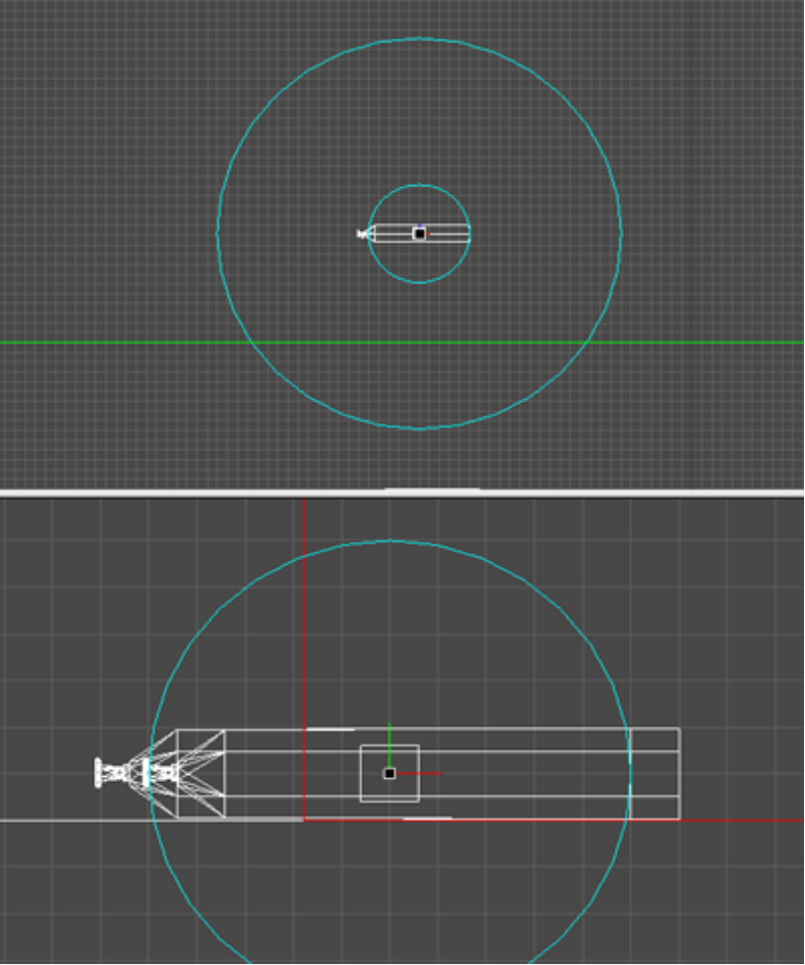
Set the following flags on the Explosion object:
ImpactFXName: AcidGas
DamageType: Explode
DamageRadiusMin: 50
DamageRadius: 200
MaxDamage: 300
RemoveWhenDone: True
ImpusleForce: 12000

Place the Impulse

The Impulse is the object that will serve as the motor that drives and propels the tank forward once it has been damaged. We are going to be using a PhysicsImpulseRadial. A PhysicsImpulseRadial will affect ALL “rigid-body” physics items within its radius. You could use a PhysicsImpulseDirectional instead of a PhysicsImpulseRadial, but using the radial allows the tank to kick around other small items that it passes directly over. MUCH cooler!
- Place the PhysicsImpulseRadial right in the middle of the valve of the tank. Direction of the rotation does not matter as a PhysicsImpulseRadial sends its pulse out equally in all directions. Name it PIRadial.
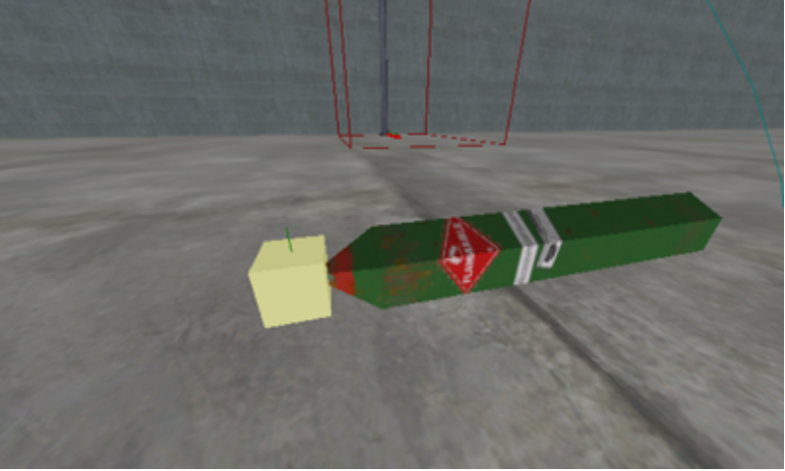
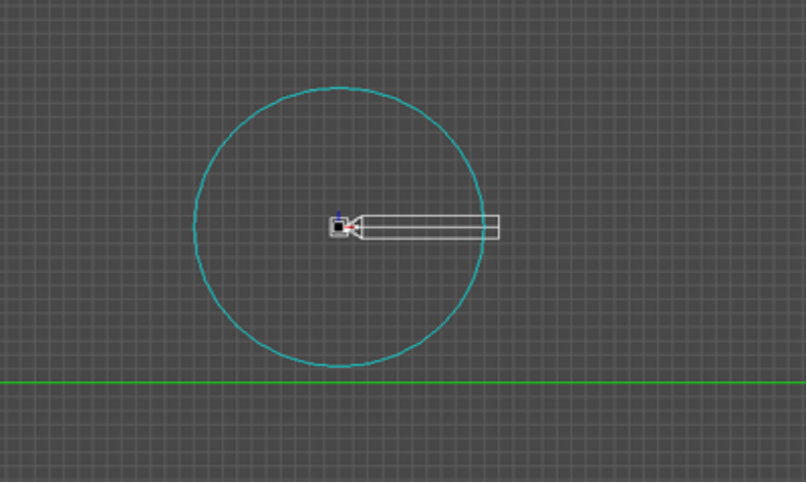
Set its flags:
ImpulseForce: 15000
RadiusMin: 100
RadiusMax: 100
RemoveWhenDone: False

Parenting

Now we need to “parent” most of these objects to the tank so they will travel along with the tank when it is moving. Some objects can be set as children or parents simply by placing them underneath or above another object in the node tree (i.e. Physics Shapes), but many other items cannot. For the ones that cannot, you will have to set them as children in another way. In this case our tank, oxy-tank, is the parent for all other items in this tutorial. Using the Attachments field you can list Objects, Models, and WorldModels that will move with the WorldModel object while maintaining their relative position and rotation. This is commonly used to add Props like door knobs to doors. List all Objects you want attached separated by a semicolon and a space.
- Go into the properties of the oxy-tank and change the following:
Attachments: SND00; SND01; SND02; SpEFX00; SpEFX01; SpEFX02; SpEFX03; Explosion; PIRadial

Script It Baby

Now you need to set up the CommandObject that will control the timing of firing off all sounds, Special Effects, explosions, etc.
- Place a CommandObject somewhere close to the tank. Its exact placement is not important. Name the new CommandObject, COB. There is one important flag to set on COB:
NumberOfActivations: 1
- Now click on the EventCommands field of COB, where we will set up the events that will happen when the tank takes damage. We will set up 2 different timelines. You might be able to get away with a single timeline, but there is a hard limit on the number of characters allowed for each event table on the timeline. I don’t think we ever did find out the exact number, but during the development of XP-1 I kept my number of characters under 130 whenever possible. So again, we need to set up 2 different timelines. Name the 1st one Go and name the 2nd one Go2. Set an event on Go at 0 seconds. Set an event on Go2 at 0 seconds as well.
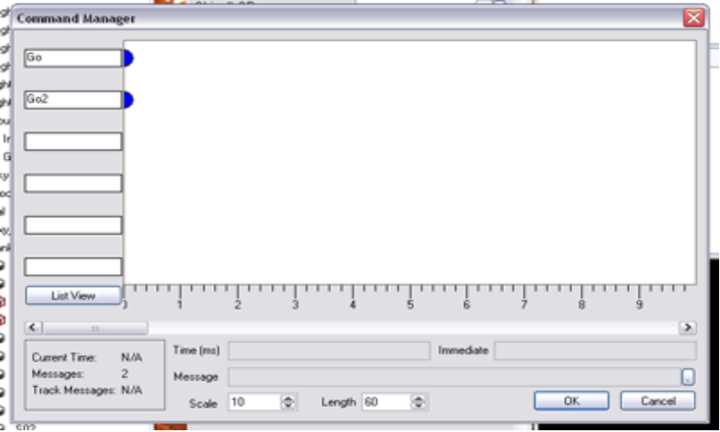
- Now, pull up the event table for Go and type in the following:
msg PIR on;
msg SFX00 on;
msg SFX01 on;
msg SFX02 on;
delay 0.5 (msg PIR on);
delay 1.0 (msg PIR on);
delay 1.5 (msg PIR on);
delay 2.0 (msg PIR on);
delay 2.5 (msg PIR on);
delay 3.0 (msg PIR on);
delay 3.25 (msg SFX03 on);
delay 3.5 (msg EXP on);
delay 3.5 (msg tank remove);
- Pull up the event table for Go2 and type in the following:
msg S00 on;
msg S01 on;
delay 3.25 (msg S02 on);

Now, this could have just as easily been set up using a Trigger instead of a CommandObject, and if you prefer to do it that way, go for it. Or you can use this CommandObject and instead of the delay commands you could actually put those commands in on the timeline instead. In the end, it’s up to you. And honestly, most of the time, putting commands on the timeline is the better way to go.

Damage Properties of the Tank

Now we just need a way to start the COB. We will set things up so that when the tank takes ANY damage from ANY source, it will start the COB and set everything into motion.
- Select your parent WorldModel, oxy-tank, bring up its DamageProperties and add the following line to the DammageCommand:
msg CO on;
- Then set the following flags in the DamageProperties:
DamageTriggerNumSends: 1
CanDamage: True
DamageMask: <none>

Save, Compile And Run

Now it’s time save out your work. So save the world, then compile the world and run it. Once the world has loaded, press F7 to get weapons and then shoot the new tank you’ve made. It should shoot across the room and explode.

Have fun!

